**Mystery 2.0**

***Stego***

**Challenge:**

Another mystery!

Attached - another_mystery.png

**Approach:**

PNG image so we can’t use stegseek :((

No worries, we use the other tool “zteg”

That’s all!

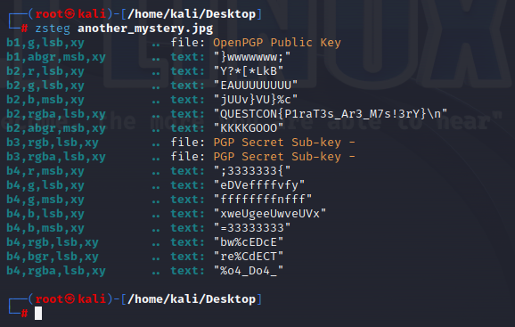

The zsteg tool is used to look for hidden messages in the Least Significant Bytes (LSB) of the document. A very common method to hide secret messages in steganography.

**Flag: QUESTCON{P1raT3s_Ar3_M7s!3rY}**

Congrats!!

Happy Hacking!